Order Of Service

Singing: Psalm 47—CW page 85

Reading: Psalm 107:39-43

Opening Hymn: TLH 61

Reading: Acts 26:24-32

Request Hymn: CW Supplement 702

Reading: Matthew 12:15-21

Sermon Hymn: TLH 395

Sermon Text: Mark 11:21-26

Faith And Prayer

Prayer

The Apostles’ Creed, TLH page 12

Holy Communion

The Lord's Prayer

The Blessing

Closing Hymn: TLH 396

* * * * * * * * * * *

Bible Study: Lambs: Wolverine
Sheep: Proverbs 21:21-25
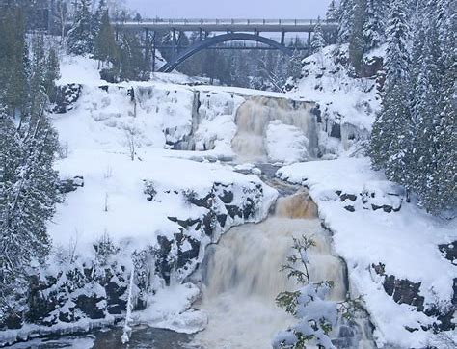

Winter In Duluth, MN

Water
Of
Life

22 December 2019

W A T E R O F L I F E

Independent Christian Church—Conservative Lutheran Doctrine

Worship Service: 9:30 a.m. Bible Study: 10:45 a.m.

Larry Cooper, Pastor E-Mail address:
111 N. Ridge Road lcooper@wateroflife.cc
Coon Valley, WI 54623 Web Site:
www.wateroflife.cc

* * * * * * * * * * * * * * * * * * * * * * * * * * *

Sermon Text: Mark 11:21-26

Faith And Prayer

* * * * * * * * * * * * * * * * * * * * * * * * * * *

Mark 11:21 And Peter calling to remembrance saith unto him, Master, behold, the fig tree which thou cursedst is withered away.
:22 And Jesus answering saith unto them, Have faith in God.
:23 For verily I say unto you, That whosoever shall say unto this mountain, Be thou removed, and be thou cast into the sea; and shall not doubt in his heart, but shall believe that those things which he saith shall come to pass; he shall have whatsoever he saith.
:24 Therefore I say unto you, What things soever ye desire, when ye pray, believe that ye receive them, and ye shall have them.
:25 And when ye stand praying, forgive, if ye have ought against any: that your Father also which is in heaven may forgive you your trespasses.
:26 But if ye do not forgive, neither will your Father which is in heaven forgive your trespasses.

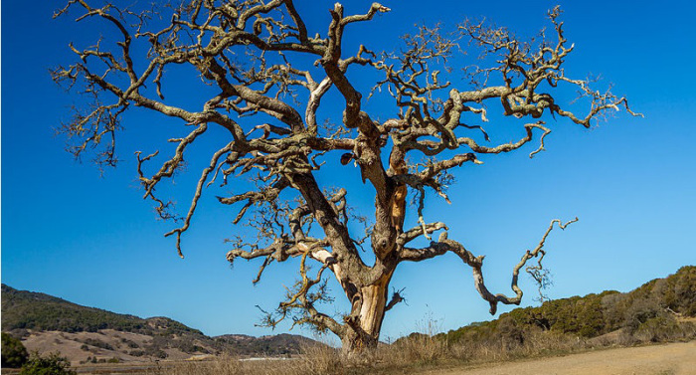

Withered Fig Tree

